THE CENTRAL BANK OF THE REPUBLIC OF ARMENIA

Approved under Board of the Central Bank

Resolution No. 195 A,

dated 13.08.2013

Inflation Report

Monetary Policy Program, Q3, 2013

⬅

Status report on implementation

of the Monetary Policy Program

Q2, 2013

Table of Contents

1. Executive Summary...........................................................................
2. Forecast, forecast changes, risks .....................................................
2.1. External environment ..................................................................

2.2. Aggregate supply and Aggregate demand ................................

2.3. Inflation forecasts and monetary policy directions in a 3-year forecast horizon ..................................................................
3. Actual Developments in Q2, 2013 ...................................................

3.1. Inflation .........................................................................................

3.1.1. Actual inflation and attainment of target .............................

3.1.2. Import prices and producer prices .......................................

3.1.3. Inflation expectations ............................................................

3.2. Aggregate supply and Aggregate demand .................................

3.2.1 Aggregate supply .....................................................................

3.2.2. Aggregate demand ..................................................................

3.2.3. Labor market .............................................................................

3.2.4. Fiscal policy ..........................................................................

3.3. Money and financial market developments ............................

3.3.1. Financial market, money and credit ....................................

3.3.2. Exchange rate .........................................................................

3.4. Balance of payments ...................................................................

3.4.1. Current account ......................................................................

3.4.2. Capital and financial account ...............................................

3.5. External environment ..................................................................
4. Conclusion ..........................................................................................

Since January 2006 the Central Bank of Armenia has moved to a fully-fledged inflation targeting strategy whereby the monetary policy was steered to minimize any deviations of potential inflation from a 4 percent target.
Each quarter, the monetary policy programs of the Bank used to present inflation forecast for the upcoming 12-month period under the assumption of unchanged interest rates as well as forecasts of the response of the policy rate. The programs included a blueprint for monetary policy directions.
The forecasting and policy analyses capacities of the Bank have considerably improved recently as the quarterly projections model became a more sophisticated one while the list of short-term models designed to forecast different suites of macroeconomic indicators expanded. Not only the Bank is now able to present inflation forecasts for upcoming 12-months but also it can provide medium-term conditional inflation forecasts.
Starting from Q2, 2012, the Bank has expanded inflation forecasts for a longer time horizon of 3 years instead of previously applied 1-year and publishes non-conditional inflation instead of conditional.
In consideration of best international experience, public surveys as well as seeking to raise public awareness the Bank approves and publishes, starting from the second quarter of 2012, Status Report on Implementation of Monetary Policy of the previous quarter and Monetary Policy Program of the next quarter in a single paper.
1. EXECUTIVE SUMMARY

The second quarter of 2013 was remarkable for high inflationary environment determined by events (heavy hails and partly postponed vegetation period) in agriculture as well as some rise in service prices that time. As a result, the 12-month inflation rate in end-June was 6.5%, above the upper bound of the confidence band. Moreover, during the quarter the 12-month inflation went an up-sloping path, from 4.2% in the previous quarter to 5.5%, which was mainly due to the rise in service prices.
The second quarter of 2013 was remarkable for high inflationary environment and slowed economic growth rates.
In the second quarter of 2013 economic growth rates slowed down, and there will be 5.5-5.7% economic growth instead of 6.3-6.7% growth expected for the first half of 2013, according to the Central Bank estimates. This is mainly due to negative developments in construction.
In the forecast horizon, economic growth will be 4.7-5.3%, mainly due to the growth in industry and services (with a combined contribution of about 3.8 pp).
Also, in the second quarter the Government implemented a more contractionary fiscal policy than planned – the collection of taxes was over-performed and expenditures were curtailed.
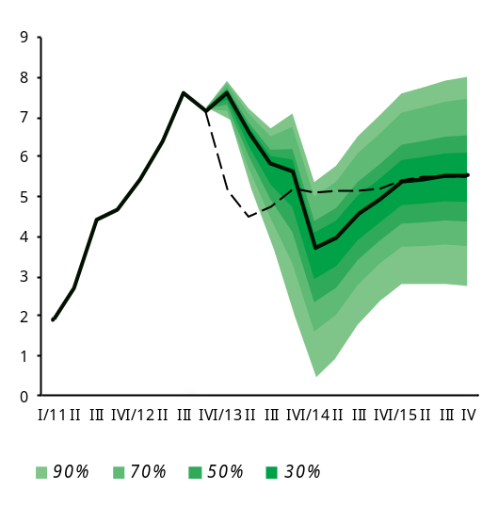
As was outlined in the second quarter monetary policy program, the impact of phasing out agricultural supply shock had to also help reduce the excess growth of real private consumption. In the second quarter the real private consumption growth rate slowed down to 4.8% y/y. Decline in construction output resulted in more-than-expected reduction in private investment (an estimated 2.8%) in the second quarter.
Real GDP cumulative growth projection probability distribution for 3-year horizon_wrong graph
w
Current projection

January 2013
projection

In the forecast horizon, private consumption growth rates will stabilize while private investment will start slowly recovering from the third quarter. In this case, the growth of private consumption in 2013 will reach 4.5% whereas private investment will stay at the previous year's level. Net export growth will reach 6-7% owing to increased exports and reduced imports. As a result, the economic growth will be 4.7-5.3%, mainly due to the growth in industry and services (with a combined contribution of about 3.8 pp).
In the forecast horizon, domestic prices will feel little deflationary pressures as the private demand stabilizes and the fiscal policy implementation remains an estimated neutral.
In external sector in the second quarter of 2013 world demand remained sluggish primarily due to the problems in European Union, although economic growth rates in the U.S.A. have accelerated to some extent. In such conditions no inflationary trends were observable in basic food and raw material markets of the world, and even some markets started seeing deflationary patterns.
In the forecast horizon, no inflationary pressures will be seen in the external sector. It is anticipated that world economic growth rates will slowly recover, so, driven by a sluggish external demand, international prices of major raw materials and food products will behave relatively steady.
In external sector in the second quarter of 2013, world demand remained sluggish mainly due to the problems in European Union; in the forecast horizon, external sector remains non-inflationary while prices in basic food and raw material markets of the world will behave relatively steady.
In the light of the aforementioned developments in external and domestic economies, in the second quarter of 2013 the 12-month inflation went an up-sloping path and reached 6.5%, which is more than predicted and one percentage point higher than the upper bound of the band.
In the second quarter of 2013 the Central Bank further carried out a neutral monetary policy by leaving the refinancing rate unchanged.

In the second quarter of 2013, in view of the transient nature of the high inflation, core inflation staying closer to the target, the positive level of real interest rates as well as the lack of inflationary pressures from external sector and domestic economy, the Central Bank continued implementing a neutral monetary policy by leaving the refinancing rate unchanged (see details in section 3.1.1 Actual inflation and attainment of target).
In an inflationary environment like this, the Central Bank will adjust the current directions of the monetary policy by raising the refinancing rate in order to mitigate second-round effects of the increase of energy tariffs and have inflation expectations anchored. It is expected that the 12-month inflation would slow and come closer to the target during 2014, whilst staying within the confidence band in the forecast horizon. In the event inflation subsides gradually and economic growth slows, the Central Bank will react accordingly by easing the monetary conditions.
However, in view of second-round effects of the increase of energy tariffs from July on domestic prices as well as inflationary expectations of economic agents, the inflation is expected to be higher in the third quarter compared to the second quarter of the previous year, as the 12-month inflation will reach 8.5% in that time.
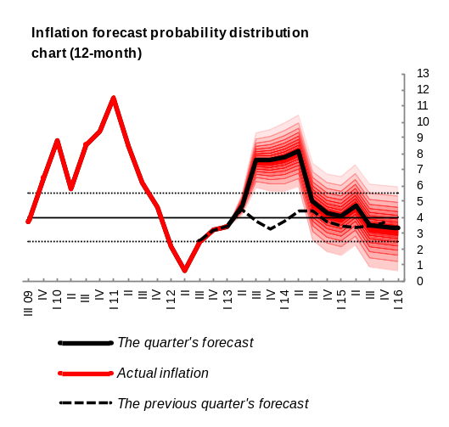In an inflationary environment like this, the Central Bank will adjust the current directions of the monetary policy by raising the refinancing rate in order to mitigate second-round effects of the increase of energy tariffs and have inflation expectations anchored. It is expected that the 12-month inflation would slow and come closer to the target during 2014, whilst staying within the confidence band in the forecast horizon. In the event inflation subsides gradually and economic growth slows, the Central Bank will react accordingly by easing the monetary conditions.
The risks that inflation would deviate from the forecast value are estimated downside, reflecting risks to the slow recovery of the global economy as well as possible weakening of the domestic demand. If such risks materialize, the Central Bank will respond accordingly, making sure the inflation target is attained in the medium term. The inflation risks in the medium term are balanced.
2. FORECAST, FORECAST CHANGES, RISKS

2.1. External environment

Sluggish global economic recovery will create a low inflationary environment in the external sector.
Sluggish global economic recovery will create a low inflationary environment in the external sector.
In July of 2013, the IMF readjusted world growth outlook indicator downside and predicted 3.1% and 3.8% economic growth for 2013 and 2014 respectively, by lowering the indicator 0.2 pp for either year.
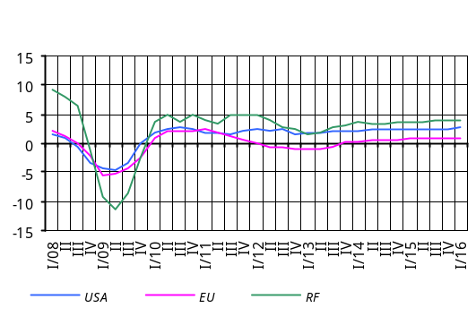In the U.S.A. the Federal Reserve System will continue implementing a low-interest-rates policy during 2013, too. However, some contraction of certain leading indicators of quantitative easing can be expected. It is anticipated that, starting the second half of 2013, economic growth rates will accelerate to reach 2.7% in 2016.
Economic recovery in Euro-area will be at quite a slow pace.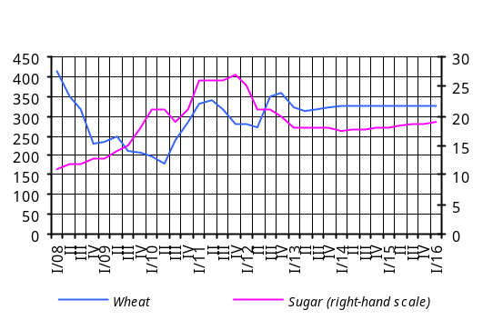 Driven by real sector problems economic recovery will be put off until 2014, and it will reach 1 percent at the start of 2016. In pursuit of economic stimulation, the European Central Bank will continue a low-interest-rates policy.
The forecast of economic growth in Russia for 2013 is about 2.4%. At the end of 2016 that indicator is expected to reach 4.1%. The inflation indicator will be within 7% in 2013.

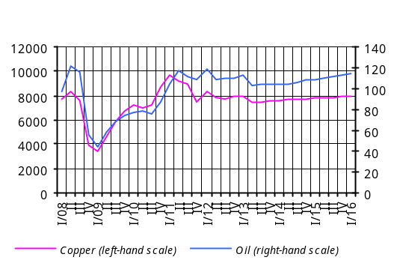Uncertainties and risks about the further pace of global economy are persisting. Still, developed countries are better off in terms of confronting such eventualities. However, risks to the slowing of economic activity in developing countries have grown considerably.
In the face of expected sluggishness in world economic recovery no significant inflationary trends will be observed in the world’s main commodity and food product markets. Moreover, individual commodity markets are predicted to develop under the influence of fundamental factors inherent in any such markets. Risks associated with energy price developments will be determined by geopolitical events, the performance of metals prices will be influenced by world economic growth outlook whereas prices of food products will depend mainly on weather conditions.

Box 1

Developments in commodities markets in the forecast horizon
In 2013 roughly 66.3% of global demand for oil will be met by producing oil by non-OPEC countries (the growth was 0.6% against the previous year), under which circumstance average demand for extraction of oil by OPEC countries will reach 36.2 million b/d. In the period 2013-2016 international oil prices are expected to grow moderately as world economic activity rebounds. However, the global market of energy resources will possibly see inflation risks due to geopolitical developments.
Uncertainties are anticipated in base metals markets, whilst inflationary trends will not be seen. In the period 2013-2016, however, moderate inflationary patterns may be observed as the world economic recovery is back on track.
In world wheat markets the fundamental tightness has somewhat weakened, yet further developments in the market will depend on the information about new crops. According to July estimations of the U.S. Department of Agriculture, in the marketing year 2013/2014 some 697.8 million tons of wheat crops is expected (an increase of about 42.5 million tons compared to the previous year) in consideration of world consumption of 699.9 million tons. The international wheat price is mainly expected to show stabilization trends.
In the marketing year 2013/2014 world production of rice will be 478.8 million tons. On the back of anticipated demand of 476.1 million tons, the world rice stock will amount to 108 million tons for the marketing year 2013/2014. Under such conditions the rice market will see price stabilization trends.
International sugar prices are mainly expected to show weak deflationary trends attributable to rich crops recorded for the marketing year 2013/2014.

2.2. Aggregate supply and Aggregate demand

Aggregate supply
In consideration of current macroeconomic developments, a slow pace of economic recovery and expected slackening of domestic demand, economic growth forecasts under the baseline scenario for 2013 were revised slightly downside. As a result, economic growth in 2013 will be in the range of 4.7-5.3%, while in the forecast horizon it would stabilize around 5-6%, staying close to its long-term equilibrium.
A slow pace of global economic recovery and sluggish growth in domestic demand urged to revise the 2013 economic growth slightly downside.

The developments are expected in the sectors of the economy, as follows:
Real GDP cumulative growth projection probability distribution for 3-year horizon wrong graph

For Industry the forecasts were revised slightly downside primarily due to the developments in the branch in the first half of 2013 as well as expected slowing in external and domestic demand. The growth of industry will continue to be driven by such sub-industries as ore mining, metallurgy, food and beverage, diamond processing and pharmaceutics. As a result, in 2013 the real growth of value added is expected in the region of 7.2 – 8.7% y/y.
Current projection

January 2013
projection

There are risks to somewhat slower growth rates mostly due to possible slowing of the global economic growth rate.
For Construction forecasts of value added were revised downside, based on reported decreases in value added earlier the year, somewhat worsened expectations of companies7 in the branch and a postponed major road construction project. The value added in 2013 will be maintained at the level close to the previous year’s.
In construction risks are balanced and depend on quicker implementation of infrastructure improvement projects and road construction For Services the forecasts were left, virtually, unchanged. This is mainly attributable to domestic private and public consumption forecast figures which stayed almost the same after their revision. As a result, the real growth of value added of services is forecast in the range 5–6.5% y/y for 2013.
Risks to slower growth rates will be determined by possible slowing of remittances to disposable household income and more-than-expected contraction in private spending due to increased energy costs.
For Agriculture forecasts remained almost the same, and the real growth of value added is expected within 1.8–3.3% for 2013. Given the high share of plant growing and how heavily the sub-branch relies on climatic conditions, pessimistic scenarios were taken into account when forecasting the developments in agriculture.
In agriculture risks are balanced and are determined by their heavy reliance on the weather.
Under the baseline scenario, in the forecast horizon risks to economic growth are dual-sided and associated with both exogenous and indigenous factors. Moreover, the downside risks, however insignificant, outweigh the upside risks.
Under the baseline scenario, in the forecast horizon risks to economic growth are dual-sided; however the downside risks outweigh.
Real GDP Growth (Cumulative) Projection Probability Distribution
Period | 90% probability interval |  | 30% probability interval
Period | Min | Max | Min | Max
January-December 2013 / January-December 2012 | 3.5 | 6.1 | 4.7 | 5.3

Labor market8: the 2013 forecasts of labor market indicators were revised slightly downside, according to the baseline scenario. This was based on somewhat slower-than-expected economic activity in relation to previous forecasts.
In view of actual wage developments in the period January-May and expected slowing in the economic growth rate, the 2013 forecasts of wage growth rates were revised downside. Given the economic growth and inflation developments follow the projected path in the baseline scenario, the above-mentioned trends in labor market will continue in the medium-run as well.
In particular, in 2013 average nominal wages are expected to grow by 3.8% mainly thanks to an increment in wages in the private sector on the back of some increase in wages in the public sector. Moderate growth in productivity in the private sector and adjustment of nominal wages in line with the anticipated inflation environment will contribute to the growth of wages in the private sector. The rise of minimum salary threshold of AMD 35,000 to AMD 45,000 at the beginning of the third quarter of 2013 will also somehow contributed to the expected growth of nominal wages in both the private and public sectors.
In spite of the anticipation of a slower economic growth, the unemployment rate in the economy is expected to decline faster, compared to previous forecasts, due to a rapid fall in unemployment in the first half of the year compared to projections . According to Central Bank estimates, the average unemployment rate in 2013 will reduce by 2.1 pp compared to the previous year, to 15.2%.
The level of unemployment will keep on subsiding in the medium-run. In the forecast horizon, in the light of declining unemployment and the government policy steered to wage increment, the growth rates in nominal wages will be even faster which will lead to much higher growth rates in real wages.
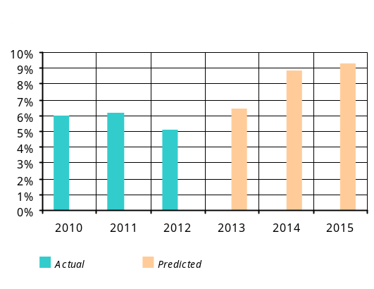Under the aforementioned developments significant imbalances that would affect inflation in the labor market is not likely to appear over 2013 and in the medium-run. The studies of inflationary impact from the labor market have also considered the Government action, now and ahead, designed to increase wage in both private and public sectors.

Aggregate demand9
Relative to previous forecasts, the growth rate of private consumption for 2013 has not changed much, and it amounts to 4.5%. In 2013 the private consumption growth rates will slow down, reflecting an excess growth of private consumption phased out in 2012.
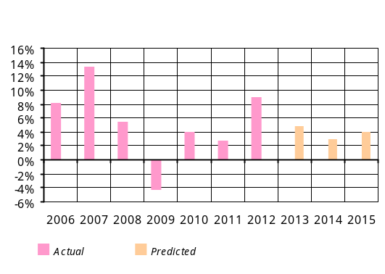The expected decline in agricultural output and contraction of volumes of loans to the economy as well as a rise in energy prices will determine the behavior of private consumption in the forecast horizon. Furthermore, growth rates of private consumption will decelerate at the beginning of forecast horizon, will be relatively low in 2014 and should stabilize around 4-4,5% in the period 2014-2016.
In the second quarter of 2013 investment activity in the economy was somewhat weaker than anticipated, reflecting some contraction in the output volumes in construction in the period April-June. As a result, the forecasts of private investment for 2013 were revised downside.
In 2013, relative to the previous year, the private consumption is expected to grow by 4.5% while the level of private investment will remain unchanged.
Although investment flows were less-than-expected in the second quarter, the companies’ propensity to invest was somewhat stronger compared to the first quarter. Given the expected economic growth in 2013, higher activity in the construction branch in the second half of the year, one may see some improvement in investment flows in the second half of the year.
In view of the aforementioned developments, the Central Bank estimates that the private investment rate in 2013 will not change much compared to the previous year.
Growth rates of private investment in medium-run will be slightly faster compared to 2013 thus contributing to the expected economic growth for that period. In the forecast horizon private investment will recover somewhat slower than outlined in previous projections, due to the influence of possible revision of prices of energy resources on the economic activity.
In view of the developments with private consumption and investment mentioned above, the growth rate of private spending will decelerate in the forecast horizon and will stabilize around 4.5-5% at the end of the horizon. As a result, the private spending gap is estimated to be negative at the beginning of horizon and will stay so in the medium run and eventually wane out to zero in the closing of horizon.
In the second half of 2013, the private spending will create some 0.4–0.5 pp of contractionary impact on inflation and 0.8-0.9 pp of contractionary impact in the medium-run. At the end of the horizon, the impact of private spending on inflation will be neutral as the private spending gap narrows.
In the face of somewhat weaker global economic recovery, slowing of the domestic economic activity and expected developments, forecasts of individual components of current account were revised, and the Current Account/GDP ratio posted faster improvement and even will outgrow expectations during 2013. The growth of real export volumes will be concurrent with the reduction in real import volumes in 2013, which will lead to the reduction of the dollar value of the balance of trade deficit in spite of estimated deterioration of terms of trade. The growth rates in private remittances of individuals remained unchanged in relation to the previous projections in anticipation of the developments in the Russian economy.
Taking into account the export growth in the second quarter in 2013, expected developments in the domestic industry and persisting weak external demand, the export growth indicator for the second half of the year was revised somewhat downside. As a result, in 2013 the growth of real export of goods and services will be in the range of 7.0–9.0%. The downside risks to export will prevail due to the slowing in global economic growth rates.
In 2013 the growth of real export of goods and services will be in the range of 7.0-9.0% while decline of real import of goods and services is expected in the range of 0-2.0%; the growth rates of non-commercial remittances of individuals are estimated within 6–8% for 2013.
The import growth indicator was also revised downside in consideration of revision of growth rates of domestic economy. At the same time, taking into account the y/y contraction of import of goods and services in the first half of 2013, the decline in real import of goods and services is expected within 0–2.0%. Risks to import will remain downside, reflecting the developments in the domestic economy.
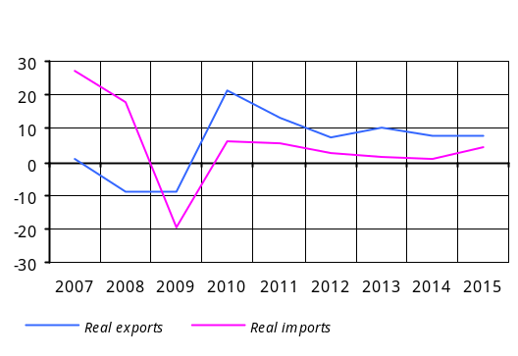 The growth rates of non-commercial remittances of individuals are estimated in the range of 6–8% for 2013. Although growth rates in non-commercial transfers slightly accelerated in the second quarter, the forecast remained unchanged, however, in view of the slowing of the Russian economy.
All aforementioned adjustments suggest that the Current Account Deficit/GDP ratio will reduce to 8.0–9.0% in 2013 from 9-10% as was provide for in the previous program.
As for the medium-term developments, the current account may possibly develop so that it helps achieve external equilibrium faster.
In view of the H1, 2013 state budget performance which was consistent with the projections (see section “Actual developments in fiscal policy”), the annual budget program was revised as follows: savings on public expenditures to make up 3% of annual expenditures and over-performed revenues to reach 2.3% of the annual plan. In 2013 the Tax/GDP ratio is expected to increase by almost 1.0 pp10, and the Expenditures/GDP ratio, by 0.7 pp. Furthermore, an increase of expenditures has been planned to the expense of both surpassed growth of capital expenditures11 and current expenditures. In 2013 the Deficit/GDP ratio is expected to reach 1.5 percent12.
In 2013 the Deficit/GDP ratio is expected to reach 1.5%.
In 2013 it is anticipated that the fiscal policy’s impact on aggregate demand would be minor contractionary, which would be driven mainly by contractionary influence of revenues and in part some savings on expenditures.
The impact of fiscal policy in forecast horizon has been estimated based on the main indicators as outlined in the Republic of Armenia Medium-Term Public Expenditures Program, 2014-2016, which is aimed to effective debt management and maintaining the Debt/GDP ratio up to a 2-percent level. The impact of fiscal policy in medium run is estimated to be non-inflationary, as a result.

The fiscal sector’s medium-term impact estimation according to macroeconomic indicators underlying the Medium-Term Public Expenditures Program, 2014-2016, prepared by the Republic of Armenia Ministry of Finance (% in GDP)
 | 2012 | 2013 | 2014 | 2015 | 2016
Budget revenues | 23.8 | 23.8 | 23.4 | 23.6 | 23.9
Budget expenditures | 25.3 | 25.3 | 25.7 | 25.6 | 25.9
Debt interest payment | 1.01 | 1.18 | 1.14 | 1.13 | 0.93
Budget balance13 | -1.5 | -1.514 | -2.3 | -2.0 | -2.0
Primary balance* | -0.5 | -0.3 | -1.2 | -0.9 | -1.1
One-off flows** | -0.3 | -0.4 | -0.3 | -0.3 | -0.3
Adjusted balance*** | -0.2 | 0.1 | -0.8 | -0.6 | -0.8
Cyclical balance**** | 0.1 | -0.1 | -0.2 | -0.1 | 0.0
Cyclically adjusted primary balance (structural balance sheet) | -0.3 | 0.2 | -0.6 | -0.5 | -0.8
Fiscal stance***** | -1.5 | -0.5 | 0.8 | -0.1 | 0.3
* Budget balance minus debt interest payments.
** Temporary or one-off budget entries. In this case net lending is considered; the sign “+” means resources allocated and the sign “-“ means resources repaid.
*** Primary balance sheet adjusted by one-off entries.
**** Central Bank estimate: a part of the budget balance which depends directly on the business cycles. The latter’s components depend on the GDP gap and revenues and expenditures elasticity coefficients on GDP gap.
***** Central Bank estimate: y/y change in the structural budget balance that reflects a discretionary nature of the fiscal policy (the positive sign denotes fiscal expansion and the negative sign denotes fiscal contraction).
To sum-up, the combined impact of the fiscal sector, private demand and labor market on prices in the second half of 2013 will be deflationary, 0.2-0.3 pp; in the medium-run the combined impact of the aforementioned factors is estimated again to be deflationary, with an average annual effect of 0.8-0.9 pp. This however will wane out in the end of the forecast horizon.

2.3. Inflation forecasts and monetary policy directions in 3-year forecast horizon

In the second quarter of 2013 the inflation environment expanded to some extent, as was expected, influenced by positive agricultural supply shock as it has phased out. The expanding of the inflation environment pushed the 12-month inflation up (6.5%), somewhat higher than expected, primarily due to heavy hails and partly postponed vegetation period as well as increased tariffs on some services (healthcare, air transport). As a result, taking into account the second-round effects of energy prices and inflation expectations, the inflation forecast for the third quarter was revised upside to reach 8.5%. Later, as a result of the Central Bank action, the inflation indicator will reduce gradually, returning to its target during 2014.
Forecasts of macroeconomic indicators and projection of monetary policy directions made through the Quarterly Projections Model were based on actual macroeconomic developments of the second quarter of 2013 and future information to the extent available.

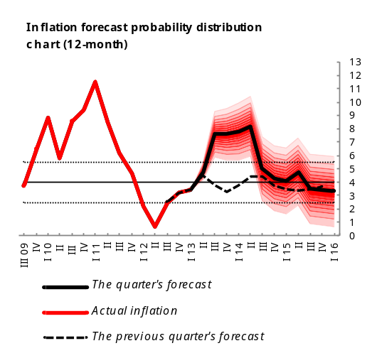 | Inflation Forecast Probability Distribution Chart
 | < 2.5% | 2.5 - 5.5% | 5.5 - 7.0% | 7.5 - 9.0% | > 9.0%
QIII | 0.0% | 0.0% | 2.3% | 89.8% | 7.9%
QIV | 0.0% | 2.1% | 31.2% | 48.2% | 18.5%
QI, 2014 | 0.0% | 4.2% | 33.9% | 43.2% | 18.7%
QII | 0.2% | 16.4% | 48.0% | 28.8% | 6.6%
QIII | 8.1% | 65.4% | 24.7% | 1.7% | 0.1%
QIV | 13.9% | 68.7% | 16.4% | 1.0% | 0.0%
QI, 2015 | 8.4% | 65.1% | 24.1% | 2.2% | 0.2%
QII | 13.6% | 68.0% | 17.1% | 1.2% | 0.1%
QIII | 15.3% | 67.3% | 16.2% | 1.2% | 0.0%
QIV | 17.2% | 65.8% | 15.7% | 1.3% | 0.0%
QI, 2016 | 18.9% | 65.4% | 14.6% | 1.1% | 0.0%
QII | 20.7% | 64.8% | 13.5% | 1.0% | 0.0%

In the face of persisting uncertainties over debt problems and geo-politics in the world, in the forecast horizon the global economy will recover at a slow pace, according to the baseline scenario. With the global demand recovering at a slow pace, inflationary pressures from the main commodity and food product markets are not likely to expect. There are certain risks associated with the decline in the growth in developing countries, which may further weaken external inflationary pressures through deflation in commodities markets and sluggish external demand.
Developments in the domestic economy are characterized by some slowing of economic activity and high inflation. The sluggish economic activity has been due to a decline in construction because of considerably low levels of investment and a restraining nature of the fiscal policy in the first half of the year, whereas inflation has accelerated as agricultural supply shock had phased out and prices of agricultural products posted some increase in part because of postponed vegetation period. Also, core inflation accelerates due to a rise in some service prices. In the third quarter in particular, increased energy tariffs will speed up the supply-driven inflation15 to make it step out the confidence band.
It is projected that in the second half of 2013 the economic growth rates will be around the lower bound of the potential. Reduced investment and cost-push inflation (given the budget constraints) will result in a negative GDP gap, which will deteriorate up until the start of 2014, contributing to the reduction in the inflation rate. A tightened monetary policy would allow restrain second-round effects of the increase of energy tariffs and have inflation expectations anchored whilst expecting that the 12-month inflation would slow and come closer to the target during 2014. At the same time, the Central Bank would, concurrent with the decrease in inflation, need to ease monetary conditions to respond to a negative GDP gap and shore up economic activity. In the outcome, the negative gap would wane out to zero. According to the Central Bank estimates, in 2013 the GDP growth will be 4.7-5.3%, staying in the medium-run within a 5-6% range.
In the forecast horizon the volumes of credit are expected to shrink. However, in absolute terms, lending will be sufficient, which will be fostered by the Central Bank’s response to the liquidity demand.
Risks to inflation deviating from forecast value in short-term perspective are estimated to be downward, determined by slower recovery of the global economy and possible weakening of domestic demand. If such risks materialize, the Central Bank will react accordingly, making sure the inflation target is attained in the medium term. The inflation risks in the medium term are balanced.

3. ACTUAL DEVELOPMENTS IN Q1 2013

3.1. Inflation

3.1.1. Actual inflation and attainment of target
In the second quarter of 2013 the inflation environment was expected to expand substantially as the baseline scenario of the Q2, 2013 monetary policy program considered the effect of phased out shock of the previous year’s agricultural supply and envisaged the potential impact from a new supply shock due to bad weather in April-May this year. Based on the actual second quarter results, there was merely 0.2% deflation compared to 3.1% deflation recorded in the second quarter of the previous year. Fast price increases were posted in items such as ‘dairy products’, ‘fruit’, and ‘vegetable and potato’. As a result, the 12-month inflation went an upward path from 3.4% at the end of March to 6.5% in end-June, thus outstripping the upper bound of the confidence band.
In the second quarter of 2013 the 12-month inflation went an upward path from 3.4% at the end of March to 6.5% in end-June, thus outstripping the upper bound of the confidence band.

12-month inflation by commodity group as main contributors
Commodity group | March 2013 (y/y) |  | June 2013 (y/y) |  | Q2, 2013
Commodity group | Growth | Contribution | Growth | Contribution | Growth | Contribution
CPI | 3.4 |  | 6.5 |  | -0.2
Food products | 3.4 | 1.8 | 8.7 | 4.7 | -1.3 | -0.7
bread products | 10.4 | 1.1 | 10.4 | 1.1 | 0.4 | 0.0
dairy products | 0.1 | 0.0 | 10.1 | 0.4 | 5.4 | 0.2
meat products | 3.5 | 0.4 | 4.2 | 0.4 | 0.8 | 0.1
fruit | 10.5 | 0.4 | 18.4 | 0.7 | 14.6 | 0.5
vegetable and potato | -8.7 | -0.5 | 17.9 | 1.1 | -26.0 | -1.6
fats and oils | 7.9 | 0.3 | 10.2 | 0.3 | 1.9 | 0.1
eggs | 11.6 | 0.2 | 18.8 | 0.3 | 1.0 | 0.0
Non-food products | 5.5 | 0.9 | 4.8 | 0.8 | 0.5 | 0.1
Services | 2.3 | 0.7 | 3.4 | 1.0 | 1.6 | 0.5

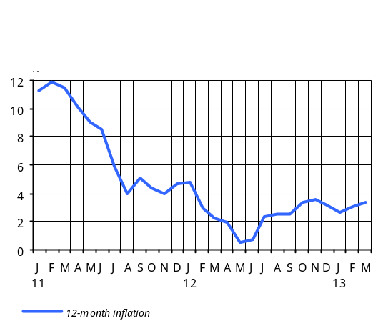In the second quarter the 12-month core inflation further expanded to 5.5.% at the end of the quarter from 4.2% recorded in the previous quarter, which was mainly due to risen tariffs on some services.
Below are the arguments and expectations which were used to predict inflation in a previous one-year horizon, as well as significant deviations in that period, which necessitated further adjustments in forecasts. Note that there was much lower inflationary environment in the beginning of the previous one-year, i.e. the start of the third quarter of 2012, which was shaped due to the supply shock as a result of increased output in agriculture. In this situation, the 12-month inflation further fell to 0.7% in late June, staying below the lower bound of the confidence band (in late June of 2011 the 12-month inflation was 8.4%, in late June of the year before, 5.8%).
A low inflationary environment as this one and the neutral stance of monetary policy for the upcoming year suggested a moderately expanding inflation environment and gradually increasing 12-month inflation rate, driven by the impact of phased out supply shock in agriculture and inflationary pressures expected from the external sector. In such a case, in the short-run the 12-month inflation rate would rise, nearing the 4% target, and would vary around this level in the forecast horizon.
The program also provided for dual-sided risks to the inflation deviating from the baseline scenario, in which case further adjustments in the monetary policy would have become possible.
In fact, as was expected, in the second half of the year the 12-month inflation rate gradually increased from 0.7 percent at end-June to 3.2 percent at end-December. This was fuelled mainly by increased food prices which, virtually, were recovering from their low levels caused by the second quarter decline in agricultural prices, on the one hand, and influence of inflationary behavior in the world wheat market on domestic prices, on the other.
Under such conditions, in the second half of the year the Central Bank further implemented a monetary policy without changing the policy rate in consideration that the influence from pronounced seasonal fall in prices of agricultural products would phase out, the 12-month inflation would gradually increase and a low inflationary environment would persist in external sector and domestic economy throughout the entire forecast horizon.
The 2013 monetary policy program envisaged a stable path for the 12-month inflation in the forecast horizon, taking into account the non-inflationary expectations from the domestic and external economies. In the short-run, inflation would accelerate in the first half of 2013, driven by the impact of phased out supply shock in agriculture in the previous year, and would then stabilize around the target.
The inflation developments in the first quarter were largely in line with the expectations: the 12-month inflation behaved rather stably, varying around a 3% level. In the second quarter, however, inflation risks emerged due to uncertainties over the agricultural year on the one hand and information on possible revision of energy tariffs from the third quarter came in on the other.
The Central Bank kept on implementing a neutral monetary policy in the first quarter of 2013, leaving the refinancing rate unchanged. Even though accelerated in the second quarter in the short-run, the inflation would return to its target value in the medium-run as the core inflation had been within the confidence band of the 12-month inflation on the one hand and inflation expectations were estimated to have been anchored on the other.

3.1.2. Import prices and producer prices
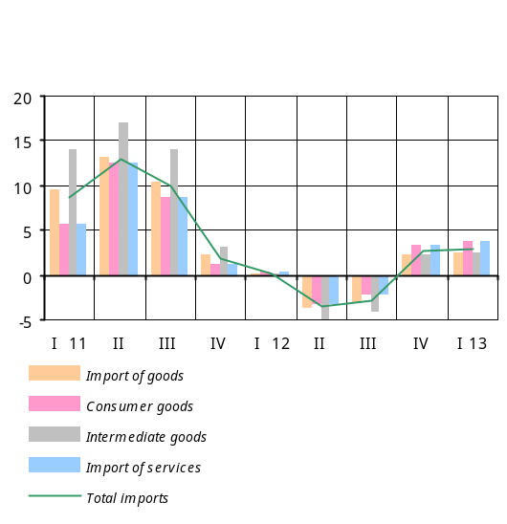Import prices: the developments in global economy as well as the US dollar’s appreciation versus euro in the second quarter of 2013 have slowed the growth rates of dollar prices of import goods. Thus, in the second quarter the growth rates of dollar prices of import fell to 1.3% y/y from the previous quarter’s 2.7% y/y growth, according to the Central Bank estimates.
The drop of growth rates of import prices was mainly attributable to decelerated y/y growth rates in commodity prices, which is a consequence of the decrease in the prices of commodities during the quarter. The y/y growth rates in consumer prices have slowed down, too.
In the first quarter of 2013 the dram prices of imported goods included in consumer basket grew an average by 7.5% y/y as the dollar prices of import goods rose by 1.3% y/y and the average nominal AMD/USD exchange rate depreciated by 3.2% y/y.
Wrong graph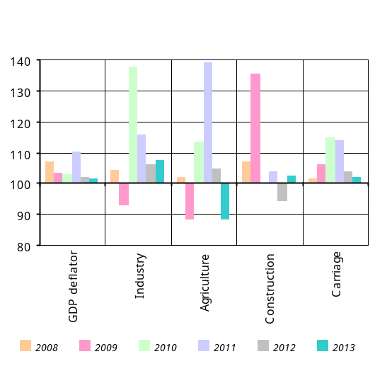Producer prices16: in the second quarter of 2013 almost all sectors of the economy (except agriculture) posted increased price indices, and the GDP deflator in the period January-June has reached 102.5 y/y, according to the Central Bank estimates.
Industry posted 2.4% y/y rise in prices, with the January-June growth of 4.8% y/y owing to increased prices in processing industry (7.9%) and energy and gas production and distribution (5.8 %).
Agriculture reported 6.5% y/y decline in prices17, with the January-June decrease having amounted to 8.1% y/y due to 14.6% and 6.4% drop in prices in plant growing and animal breeding, respectively. The reduction in prices in plant growing was driven by 12% and 27.7% decline in prices of potato and melons and gourds, and fruit, respectively. The reported price decrease in animal breeding is attributable to meat and milk and dairy product prices, having reduced by 7.8% and 5.3%, respectively.
Construction saw some 3.7% y/y growth of prices in the second quarter, with the January-June price increases having reached 2.3% y/y, mainly attributable to increased wages in the branch.
Carriage reported some 1.6% y/y increase in prices, and the price increase in the period January-June has been 1.8% y/y, owing to risen tariffs on railroad transport (2.7%), air transport (5.9%) and truck transport (2.6%).

3.1.3. Inflation expectations
In the second quarter of 2013 the Central Bank continued its regular surveys on what kind of expectations organizations in the financial sector and households have about selected macroeconomic indicators.
In the second quarter the financial sector saw increased inflationary expectations due to likely pressures from rising energy prices. Based on the second quarter results, most banks anchored their expectations of the 12-month inflation around the 5.5% range, in comparison with the previous quarter’s choice of 4%, a value within the confidence band. Credit organizations also had increased inflationary expectations by choosing the 4.8% range for the 12-month inflation figure against their previous expectation of 4% range. The second quarter survey results suggest that households’ inflationary expectations have moved upward as they chose somewhere within a 4.7% range compared to the previous quarter’s 4.3%.
According to the survey results, banks and credit organizations will further anticipate relatively stable market interest rates for the upcoming one-year horizon; in the upcoming quarter, however, they anticipate some rise in interest rates but somewhat a steady behavior in the next three.

3.2. Aggregate supply and Aggregate demand

3.2.1. Aggregate supply18
Economic growth indicator published by the National Statistics Service of Armenia was 7.5% y/y for the first quarter of 2013, as was expected.
Economic activity in the second quarter of 2013 was relatively low, and economic activity of the first half of 2013 has slowed down to 4.4% y/y from 8.7% recorded for the period January-March.
Economic activity in the second quarter of 2013 was relatively low, and economic activity index of the first half of 2013 has slowed down to 4.4% y/y from 8.7% recorded for the period January-March.
Economic growth forecasts under the baseline scenario were revised downside based on smaller-than-expected output volumes in industry, contracted trade turnover volumes and negative developments in construction in the second quarter of the year. So, economic growth in the first half of 2013 is predicted within 5.5–5.7%19.
In view of high output growth of 8.3% in Industry in the first half of 2013, the growth of value added for the first half is estimated in the range of 6.5–7% y/y mainly due to the increased volumes in metal ore mining (16.5%), food production20 (7.7%), metallurgy (10.1%), beverage production21 (11.5%), and tobacco production (74.3%), which is a result of consistent improvement in external demand as domestic and world economies recover.
In consideration of 8.8% decline in Construction in the first half of 2013, the decrease of value added for the same period of time is estimated within 5–6% y/y. Note that, save construction volumes financed by households (a 16.9% growth), the decline has been reported for all financing sources, as follows: organizations (-10.6%), international loans (-44.9%), state budget (-17%), local budgets (-22.8%) and humanitarian aid (-27.1%).
Wrong graph
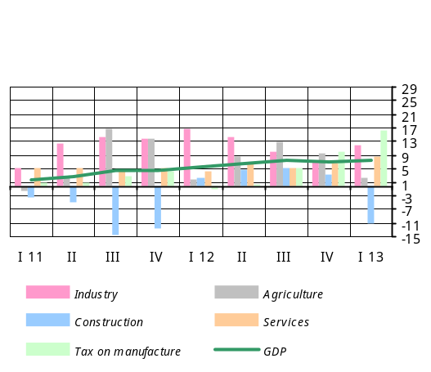In Services the growth of value added for the first half of 2013 is estimated within 5.7–6.2% y/y as a result of volumes of services rendered and trade turnover having increased by 4.4% and 3.5%, respectively. The increase in the volume of services rendered was driven by growth recorded in information & communication (10.7%), financial and insurance activity (5.8%), events, leisure and rest (17.8%), public catering (20.9%) and healthcare (13.4%). The growth of trade was totally due to retail trade and wholesale trade, having increased by 3.2% and 7%, respectively.
In Agriculture the growth of value added for the first half of 2013 is estimated in the range of 2.2–2.5% y/y, owing to increased outputs in animal breeding (1.5%), fishing (34.5%) and plant growing (3.6%). A reported 4.2% increase in milk production has totally contributed to the overall growth in animal breeding sub-branch.

3.2.2. Aggregate demand22
In line with Central Bank forecasts, the growth rates in private consumption in the first and second quarters of 2013 have decelerated compared to the previous year. 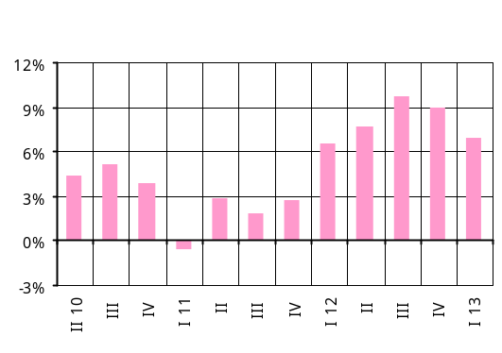In the second quarter private consumption grew by 4.8%, with a private consumption growth indicator having reached 5.8% in the period January-June.
In the second quarter of 2013 private consumption growth was 4.8% whereas private investment reduced by 2.8%.
A slowing private consumption was in part a result of gradually phased out economic effects of strong growth in agriculture in the previous year as well as sluggish credit growth.
A Consumer Confidence Index23 as calculated by the Central Bank point to the above developments with private spending. In the second quarter of 2013, relative to the previous quarter, the consumer confidence index has dropped by 8.3% to 43.3 percent, showing further tendency of slowdown.
In the second quarter of 2013 the investment climate was somewhat weaker than expected, reflecting some 8.8% decline in construction in the period January-June as well as slower-than-expected economic activity during the same period of time. So, in the second quarter investment reduced by 2.8%, while the decline in investment in the first half of the year amounted to 4.7%, according to Central Bank estimates. However, despite the decline in construction and some slowing in industry, the Central Bank survey results24 suggest that companies have positive expectations about investment as somehow slower decline is anticipated in the second half of the year. Credit provided by local banks to companies continued to be an important source of investment financing during the first half of 2013.
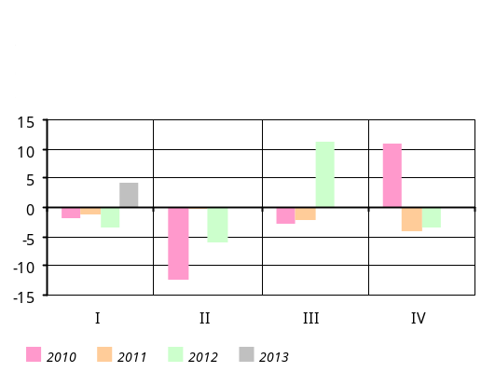In the second quarter of 2013, 26% of the companies surveyed invested in industry; this is 10 pp more than the figure recorded in the same period of the previous year. As much as 54% of the companies invested in the purchase of machinery and equipment, and 54% more used loans from local banks to finance their investment.
In the second quarter of 2013, 22% of the companies surveyed invested in construction (this is 9 pp higher from the figure recorded in the same period of the previous year). Note that the first quarter’s figure was 7 pp lower from the figure reported for the same period of the previous year.
With slowing growth rates in private consumption and less investment activity, the growth of private spending slowed down to 3.2% in the second quarter of 2013. This pushed the domestic demand to grow by 3.0% as public expenditures grew by 1.1%.
Strong private consumption and recovering private investment in the second half of 2012 generated a positive gap of private spending. In the second quarter of 2013 the gap neared to zero and had merely a 0.2–0.3 pp of positive impact on the inflation.

In the second quarter of 2013 the growth rates of export of goods and services in real terms slowed down yet remained comfortably strong. The volume of import of goods and services in real terms has contracted y/y. In the second quarter real growth of export of goods and services was 8.4% y/y conditioned by persisting high growth rates in industry.
With slower growth rates in economic activity, the real import of goods and services has reduced by 4.3% y/y, according to the Central Bank estimates.
In the second quarter of 2013 the growth rates of net inflow of non-commercial remittances of individuals somewhat accelerated and grew by11.8% y/y, in spite of slowdown in growth rates in Russia’s economy.

3.2.3. Labor market25
The developments in the period April-May of 2013 denote an estimated 2.2% rise in average nominal wages in the second quarter of 2013, somewhat a smaller increase against former forecasts. As a result, nominal wage growth in the first half of the year has been 2.8%. Moreover, in January-May of 2013 the private sector wage has grown by about 5% and the public sector reported roughly 2% rise.
Economic growth and reduced unemployment in the first half of the year were the main contributors to the nominal wage increases in the private sector.
As a result continued economic growth thus increasing demand for labor, in the second quarter of 2013 the average unemployment rate fell by 2.4 pp against the previous year and amounted to 16%. Under these conditions, the average unemployment rate has amounted to 16.45% in the first half of the year, representing a 2.3 pp reduction compared to the same period of the previous year.
Significant imbalances in the economy were not observed during the second quarter of 2013, and the impact of the labor market on inflation has been neutral, as a result.

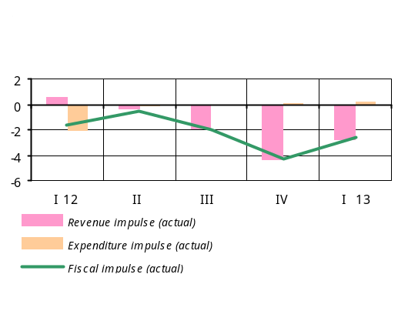3.2.4. Fiscal policy26
In the second quarter of 2013 the state budget performance was in line with revenues slightly over-collected against the quarterly plan and savings made on some expenditures items. Under such conditions, the fiscal sector further had a contractionary impact on aggregate demand – it was 2.4 contractionary instead of the projected neutral. This is mainly explained by the deviation27 reported with regard to the quarterly expenditures performance, whereby some 0.9 contractionary impact was reported instead of the projected 0.7 expansionary. The revenues impact was 1.4 contractionary against the projection of 1.0 contractionary.
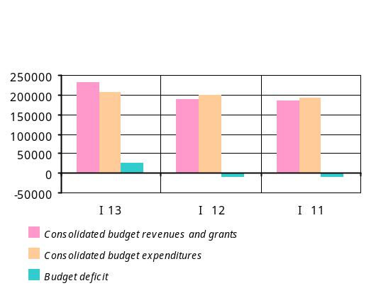In the second quarter of 2013 the performance of the budget secured AMD 1.6 billion more revenues collected against the quarterly plan.
Revenues of the consolidated budget have grown by 14.3% in relation to the same period of the previous year, mostly owing to increased tax revenues. In particular, the y/y growths of direct taxes and indirect taxes were 21% and 12%, respectively. In the structure of direct taxes, the growth of income tax28 is remarkable, 24.4%. In the structure of taxes and duties, in the second quarter of 2013, relative to the same period of the previous year, the share of indirect taxes has shrunk by 2 pp to 46% and the share of direct taxes increased by 1 pp to 44% of tax revenues.
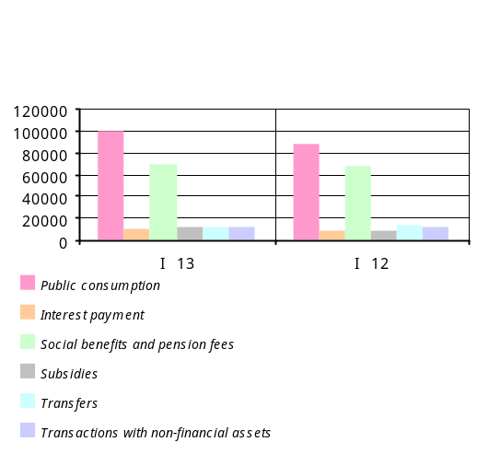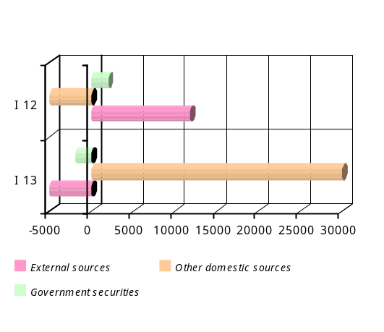Despite low performance on public expenditures during the second quarter (about 87% against the plan), almost all items have posted increases when compared with the previous reference period. In the second quarter of 2013 expenditures of the consolidated budget grew by nearly 7% against the same period of the previous year, which stands below the nominal GDP potential (an estimated 9.7%). Current expenditures have grown by about 6.9% y/y; here almost all items posted increases. Public consumption has grown by 4.3% y/y. Expenditures on item transactions with non-financial assets have grown by 23% y/y, with the deviation from quarterly plans mainly attributable to projects financed through external sources.
With revenues and expenditures figures shown above, the consolidated budget generated a surplus of AMD 7.2 billion, in lieu of an estimated deficit of AMD 24.6 billion for the quarter.
Summing up the first half results, one may note that the state budget was over-performed, with around AMD 13.0 billion more revenues and AMD 10.8 billion more tax revenues29, mostly due to high economic activity during the first quarter in particular. The growth of tax revenues has been 21.1%, or AMD 83.6 billion against the previous reference period, which is largely due to increased value added tax, customs duty, and environmental and natural resources fees. The growth of public expenditures (PIUs included) over the same period of the previous year has been 8.6%.
Based on the first half results, the state budget has generated a surplus of AMD 26.5 billion in lieu of an estimated AMD 46.9 billion deficit for the same period of time.
Overall, the first half’s fiscal policy has had a 3.2 contractionary impact on aggregate demand, driven mainly by contractionary influence of revenues.

3.3. Money and financial market developments

3.3.1. Financial market, money and credit
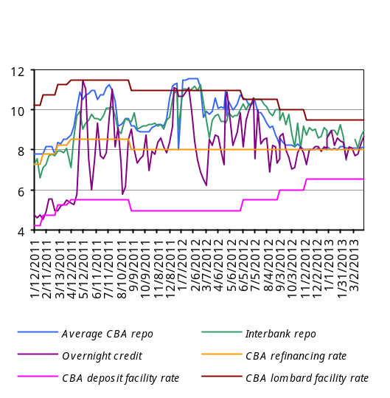 The Central Bank further conducted a neutral monetary policy during the second quarter in spite of the possible emergence of inflationary risks in the short-run, in which case though the policy rate would need to be readjusted in order to absorb inflationary expectations and second-round effects. Yet, a moderate inflationary environment during the second quarter allowed leaving the Refinancing Rate unchanged, at an 8 percent level, with the reasoning that a positive real interest rate would help anchor inflationary expectations and foster economic activity.
In the first quarter of 2013 interest rate of repo agreements, a principal instrument of the Central Bank, was 8.09 percent.
In the meantime, with a view to facilitating the provision of dram loans by banks and prop up demand for government bonds, in June of 2013 the Central Bank lowered reserve requirement ratio for dram liabilities down to 4%. However, the reserve requirement ratio for dollar liabilities remained 12%, which aims to reduce the level of dollarization.
In the second quarter of 2013 interest rate of repo agreements, a principal instrument of the Central Bank, was 8.19 percent, again close to the interest rate of the Refinancing Rate.

Central Bank operations in the second quarter of 2013
Period | Repo (up to 7 days) |  | Funds attracted |  | Lombard repo
Period | Value  (million Dram) | % | Value  (million Dram) | % | Value  (million Dram) | %
QI 2012 | 151932.32 | 11.15 | 380600 | 5.00 | 59093.88 | 11.00
QII | 185000.00 | 10.29 | 317950 | 5.05 | 179437.37 | 10.77
QIII | 488921.68 | 9.03 | 158200 | 5.51 | 32524.98 | 10.50
QIV | 741880.51 | 8.09 | 140150 | 6.22 | 5631.79 | 9.50
QI 2013 | 763825.90 | 8.09 | 163700 | 6.50 | 944.60 | 9.50
QII | 929077.62 | 8.19 | 176300 | 6.5 | 38652.30 | 9.5

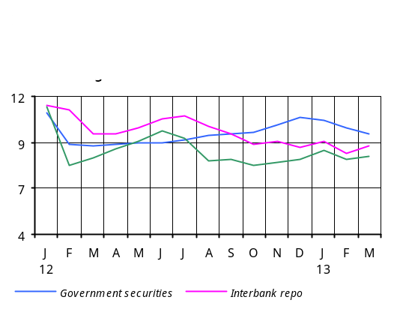With the refinancing rate remained unchanged and reserve requirement ratio for dram liabilities lowered during the second quarter, interest rates in the financial market trended slightly down compared to the previous quarter, as follows: the overnight loan interest rate has dropped by 0.18 pp, the market repo rate stayed very much the same, the interbank repo market rates has fallen by 0.25 pp and the interest rate of short-term treasury bill, by 0.58 pp.
The drop of interest rates of repo agreements prompted reduction in short-term market repo rate during the first quarter of 2013.

Box 2
Government securities market
In the primary market of short-term government bonds, interest rates further trended downward in the second quarter of 2013. As a result, the average quarterly yield of government bonds has fallen by 0.58 pp compared with the previous quarter to 9.19%, while in June the average interest rate of T-bills dropped by 0.50 pp relative to March of 2013 and amounted to 8.96%.
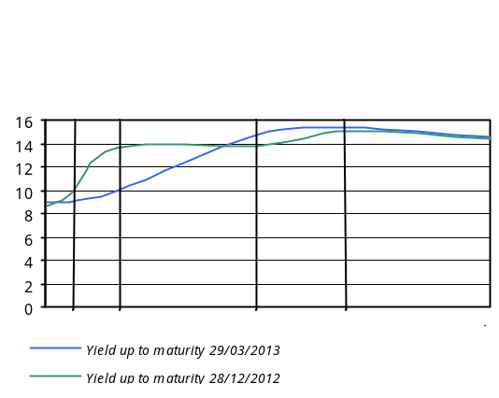The yield curve analysis shows that in the secondary market the yields sloped down almost all along the curve, except for 1-2-year maturity segment where the yield has increased by more than 2 pp.

In the banking sector in the second quarter of 2013, average monthly interest rates of deposits in Armenian dram also tended somewhat down: following a rise in late 2012, interest rates have fallen gradually during the first half and stabilized around an 11.6% level in June, with an average quarterly indicator having dropped by 0.14 pp to 11.5%. The volumes of dram deposits have increased by 2.7%, owing to the growth of both term and demand deposits. Interest rates of foreign deposits have reduced by 1.8 pp to 6.9%. The volume of foreign currency deposits stayed much the same, with a mere 0.2% increase (2.3%, if the impact of change in the exchange rate is excluded), mainly owing to deposits attracted from households.
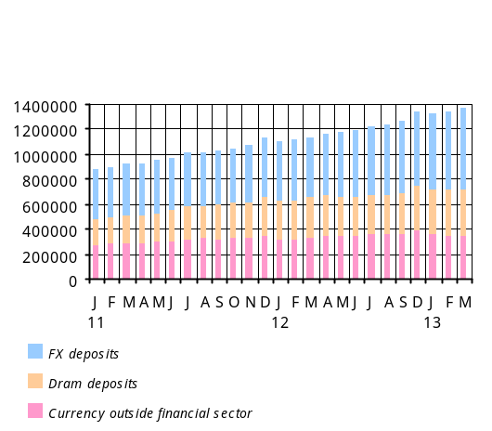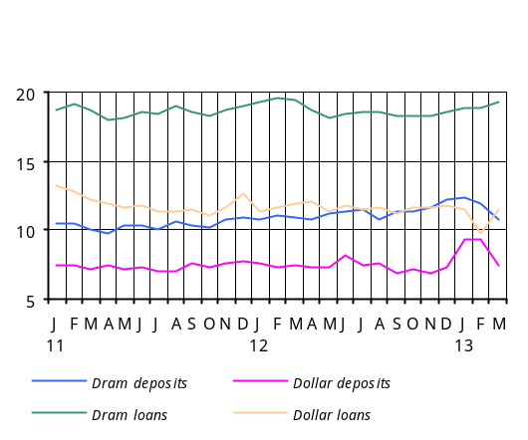Average monthly interest rates of dram loans have shown downward tendencies, too. As shown by the first quarter 2013 survey results, the small and medium-size businesses as well as households expected easier lending procedures and conditions in the second quarter. As a result, the average quarterly interest rate of dram loans has dropped by 0.8 pp to 18.2%, with average quarterly interest rate of consumer loans, mortgage loans and business loans having amounted to 19.6%, 12.6% and 14.3%, respectively.
Though the average quarterly interest rate of foreign currency loans has grown by 0.8 pp to 11.8% in the second quarter against the previous quarter, yet the average rate in June was only 0.3 pp above the average rate in March.
A narrowing trend in respect of interest rate spread between dram loans and deposits discernible in the last two years but ended in early 2013, has resumed: in June, the difference was 7.1 pp against 8.5 pp recorded in March. The interest rate spread between loans and deposits in foreign currency has broadened from 4.1 pp in March 2013 to 5.2 pp in June 2013.
The second quarter saw credit growth rates slowing, with the volumes of credit having increased by 2.1% (16.5% growth y/y) or AMD 38.1 billion in absolute terms against AMD 101.1 billion reported in the previous quarter. In the structure of credit, the volumes of dram loans have grown by 4.5% while foreign currency loans, by 0.6% (or by 2.7%, if the impact of the change in exchange rate is excluded).
The dram’s nominal exchange rate appreciation as well as almost an unchanged level of foreign currency deposits in the second quarter pushed the dollarization of the economy (measured as a ratio of foreign currency deposits to broad money) down by 0.6 pp. Foreign currency credit with slower growth rates than those of dram loans also points to the subsiding dollarization.
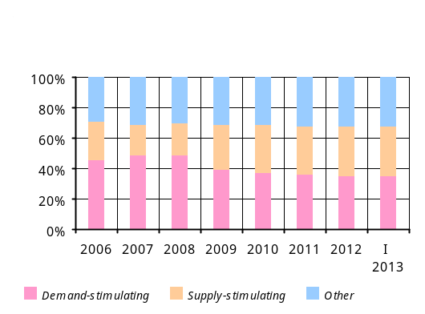
Box 3

Մի քանի միտք բաց է թողնված: Անհրաժեշտ է նախադասությունները թարգմանել ամբողջությամբ: The results of the second quarter 2013 survey on bank and credit organization lending procedures and conditions suggest that easing of such lending procedures has decelerated mostly driven by expectations for a slower economic growth on the whole. As for demand, it grew notably after the first quarter decrease. The household lending procedures (consumer and mortgage loans) were further eased. In particular, the provision of consumer loans has improved. There is anticipation of increasing demand for business, consumer and mortgage loans in the third quarter. Further easing of the procedures for business and consumer loans is expected.
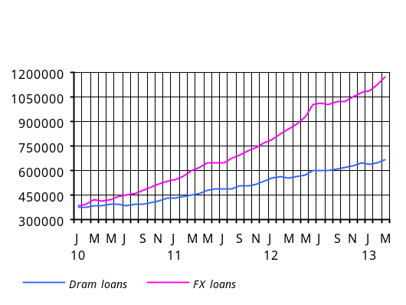

Box 4
In the second quarter of 2013 broad money grew by 1.4% to AMD 1.383 trillion and dram broad money grew by 2.5% to AMD 731.2 billion.
The annual performance of monetary indicators was as follows: relative to the same period of the previous year, dram deposits have grown by 20.1% foreign currency deposits, by 20.6% (22.9%, if the impact of change in foreign exchange rate is excluded), which pushed the dollarization up by 1.9 pp; currency has grown by 3.8%. These increases have resulted in the growth rate of broad money outpacing dram broad money (15.7% versus 11.7%). In the meantime, base money has increased by 17.0% and dram base money, by 5.7%. The money and dram multipliers in the second quarter of 2013 were 2.10 and 1.32 compared to 2.12 and 1.25 reported in the second quarter of 2012, respectively.

3.3.2. Exchange rate
The seasonal increase in demand for the dram and faster growth rates in money transfers since the second quarter of 2013 contributed to the turn of exchange rate depreciation observed since the beginning of the year. Moreover, these factors outweighed the dram depreciation pressures resulting from trade partners’ weighted currency depreciation. As a result, the dram’s nominal exchange rate demonstrated appreciation patterns during the second quarter of 2013. In the meantime, the Central Bank acted as a net buyer of foreign currency in the foreign exchange market to smooth out sharp currency fluctuations.
In the second quarter of 2013 the dram’s average nominal exchange rate depreciated by 1.3% q/q whereas the change in real exchange rate was 0.0% q/q. As for the change in the same period of the previous year, the depreciation of the real exchange rate still persisted, making up 0.8% y/y.

The real exchange rate kept on the path of y/y depreciation in the second quarter
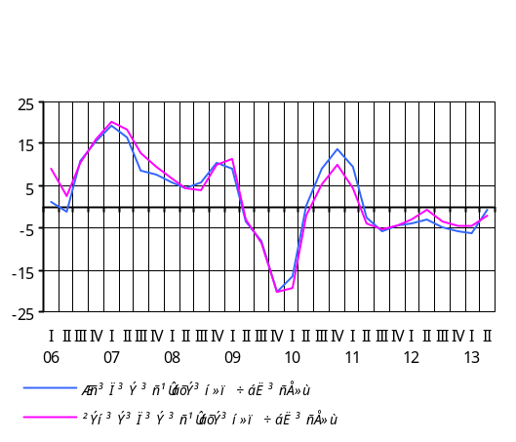y/y growth, % | QI 12 | QII 12 | QIII 12 | QIV 12 | 2012 | QI 13 | QII 13
Real effective exchange rate (+ means appreciation) | -3.8 | -2.9 | -5.1 | -5.7 | -4.4 | -6.4 | -0.8
Average inflation in Armenia | 3.3 | 1.0 | 2.4 | 3.4 | 2.5 | 3.0 | 5.2
AMD/USD average nominal exchange rate (+ means appreciation) | -5.7 | -6.8 | -10.2 | -6.3 | -7.3 | -5.1 | -3.2
Average weighted inflation in trade partner countries | 4.0 | 3.5 | 4.1 | 4.3 | 4.0 | 4.5 | 3.7
Partner countries’ average weighted nominal exchange rate (+ means appreciation versus dollar) | -2.9 | -6.9 | -7.6 | -1.7 | -4.7 | -0.4 | -1.1
Real exchange rate appreciation = Inflation in Armenia + Nominal exchange rate appreciation – Partner countries’ average weighted inflation – Partner countries’ average weighted nominal exchange rate appreciation

Box 5
Exchange rate
At the end of the second quarter of 2013, relative to the end of the previous quarter, the average market exchange rate of the Armenian dram versus the U.S. dollar has appreciated by 2.12% to 409.90 drams for one dollar.
Look at the table below to see the dram’s behavior versus the U.S. dollar, Euro and Russian ruble:

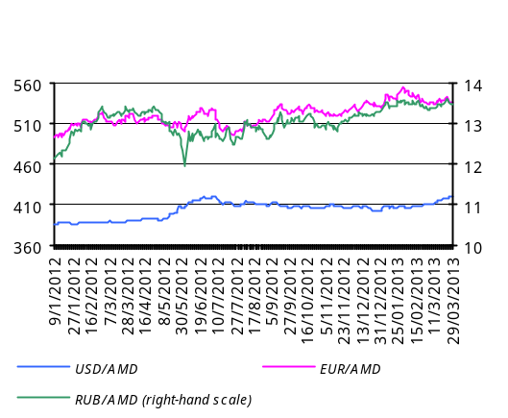Dram exchange rate dynamics, q/q, 2013
Currency pair | Exchange rate as of 31.03.2013 (AMD) | Exchange rate as of 30.06.2013 (AMD) |  | %  (appreciation +,  depreciation -)
USD/AMD | 418.58 | 409.90 |  | +2.12
EUR/AMD | 536.54 | 535.25 |  | +0.24
RUB/AMD | 13.49 | 12.53 |  | +7.66
Average dram exchange rate dynamics in Q2, 2013, y/y
Currency pair | Average quarterly exchange rate in Q2, 2012 |  | Average quarterly exchange rate in Q2, 2013 | %  (appreciation +,  depreciation -)
USD/AMD | 401.52 |  | 414.90 | -3.22
EUR/AMD | 514.93 |  | 541.69 | -4.94
RUB/AMD | 12.93 |  | 13.11 | -1.37

The aggregate volume of U.S. dollar/Armenian dram transactions in the foreign exchange market during the second quarter amounted to USD 2.3 billion, an 11.5% decrease (USD 2.6 billion) in relation to the previous quarter.
The aggregate volume of Euro/Armenian dram exchange transactions reached EUR 225.8 million against EUR 231.8 million recorded in the previous quarter.
To tackle the dram exchange rate excess volatility against the U.S. dollar in the market in the second quarter of 2013, the Central Bank bought dollar resources of USD 20.6 million.

3.4. Balance of payments30

The second quarter of 2013 saw the current account further improving in the face of slowing activity in the domestic economy, deteriorated terms of trade and sluggish global economy. Net inflow through capital and financial account has narrowed mainly due to reduced disbursement of public credit. The balance of payments developments resulted in contraction of the Central Bank net foreign assets.
In the second quarter of 2013, relative to the same quarter of the previous year, the current account deficit has reduced by USD 95.0 million to USD 250.6 million, amidst sluggish global economy and slowing activity in the domestic economy.

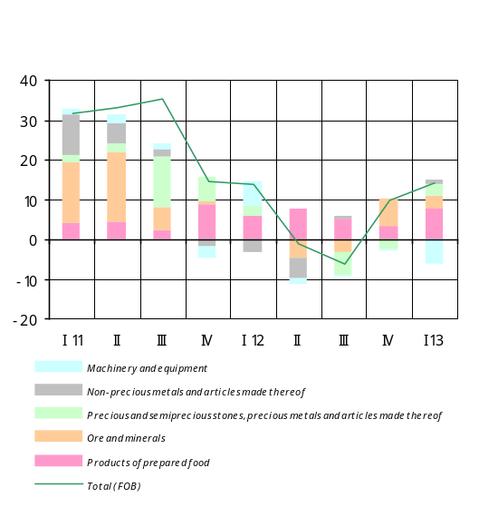3.4.1. Current account
In the second quarter of 2013, relative to the same period of the previous year, the current account deficit has reduced by USD 95.0 million to USD 250.6 million amidst sluggish rates of recovery for the global economy and slowing activity in the domestic economy.
Real export of goods kept on increasing in spite of weak external demand, and such increment was fuelled by persisted high growth rates in domestic industry in the face of dropping prices of base metals. With export prices having reduced y/y, the dollar value of export of goods grew in the second quarter by 4.0% y/y.
The growth of export has been mainly due to items “Products of vegetable origin” and “textiles”, with their positive contribution of 2.4 pp and 2.3 pp, respectively.
²⁹
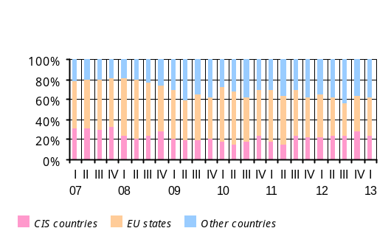The real volumes of import of goods and the dollar value posted a decrees in the second quarter of 2013 amidst slowing domestic economic activity and decelerated growth rates in dollar prices on import y/y. The dollar value of import of goods has reduced by 5.2% y/y.
The deficit of balance of services has reduced to USD 88.0 million. The y/y growth rates of export and import of services were, respectively, 7.4% and 3.8% in the second quarter.
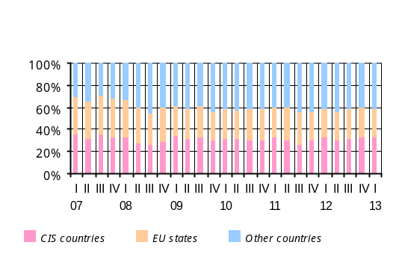In the second quarter of 2013 the y/y growth rates in remittances33 of individuals speeded up. During the quarter net inflow of seasonal worker income has grown by 12.6% y/y and amounted to USD 268.3 million, which is way above the net outflow figure in item “income on investment”. As a result, item “income” posted net inflow of USD 138.2 million. In the second quarter of 2013 the net inflow of current transfers grew by 13.3% y/y and reached USD 153.4 million.

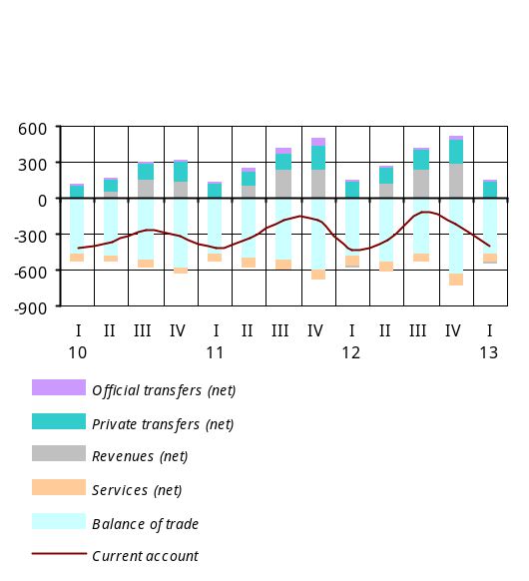

3.4.2. Capital and financial account34
In the second quarter of 2013 net inflow of the funds through the capital and financial account has reduced by USD 78.7 million y/y to USD 223.8 million. The decrement was mainly due to the delayed projects in the public sector and increased repayments. Net foreign assets of the Central Bank of Armenia have decreased by USD 26.8 million.
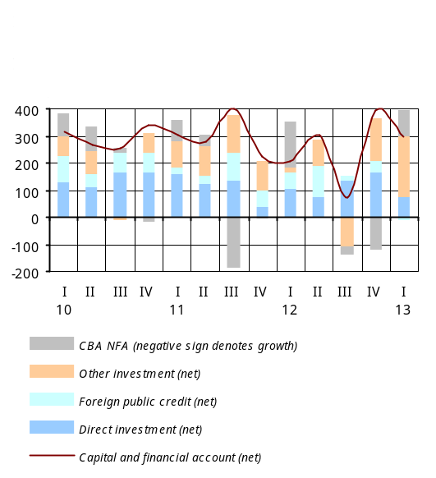In the second quarter the figure of net inflow of foreign direct investment was USD 76.3 million, much the same as in the second quarter of the previous year. The repayment on public credit exceeded the disbursements, resulting in net outflow of USD 20.9 million in contrast of net inflow of USD 116.4.8 million posted in the second quarter of 2012. After the crisis, such developments were first displayed in the first and second quarters of 2013, due mainly to some delays in inflow of funds disbursable under public credit projects. The net inflow in item “other investment” reached USD 150.8 million, with net foreign assets of banks having grown by USD 56.4 million.

3.5. External environment

In the second quarter of 2013 economic recovery trends were observable in the U.S.A. and EU, two trade partners to Armenia, whilst some slowing of growth was reported in the Russian economy.
In the second quarter of 2013 economic recovery trends were observable in the U.S.A. and EU, two trade partners to Armenia, whilst some slowing of growth was reported in the Russian economy.
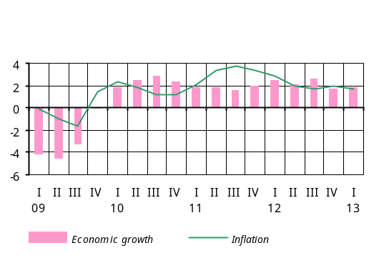According to preliminary estimates of the U.S. Department of Commerce Bureau of Economic Analyses, in the second quarter of 2013 the annualized economic q/q growth in the United States of America was 1.7% (1.4% of y/y economic growth in the second quarter) against the previous quarter’s 1.1% growth35. Positive contribution to the growth came largely from private spending and investment, whereas net exports and public expenditures made a negative contribution. In the second quarter average quarterly inflation was 1.4% y/y compared to 1.7% reported in the previous quarter.
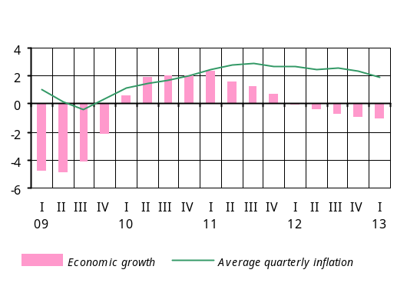In Euro-area in the second quarter of 2013 there was 0.7% percent decline against the same period of the previous year, according to preliminary figures from the Eurostat.
In the second quarter consumer price index in Euro-area rose an average 1.4% y/y, which represents some 0.5 pp drop in relation to the previous quarter.
During the quarter the European Central Bank cut the policy rate to 0.5%.
In the second quarter of 2013 Euro depreciated versus the U.S. dollar by 1%, with the average dollar exchange rate making up 1.31 for one Euro (y/y appreciation of 2 percent).
In the second quarter of 2013 economic growth in Russia slowed down to 1.2% y/y, according to the preliminary estimates of the Russia State Statistics Service. Specifically, growth rates in industry posted 0.3% y/y against 0.0% in the previous quarter; growth rates in retail trade and agriculture were 3.5% y/y and 1.8% y/y, respectively. In the meantime, construction sector reported some 3.6% decline y/y.
The rate of inflation accelerated as economic growth rates trended down. The consumer price increase was 7.2% y/y compared to 7.1% rise in the first quarter. In the second quarter of 2013 the Russian Central Bank left the refinancing rate unchanged, at an 8.25% level.
In the second quarter of 2013 the price of Brent crude at Intercontinental Exchange fell by 8.8% against the previous quarter, reaching USD 103 a barrel (with 5.4% decline y/y).
The price of copper at the London Metal Exchange dropped by 9.6% to USD 7187 per ton (with 8.2% decline y/y).
Export price of hard red wheat has dropped by 2.4% q-o-q to USD 8.5 a bushel (with 16.7% growth y/y), according to the U.S. Department of Agriculture data.
The price index of unprocessed sugar at the New York Board-Intercontinental Exchange has dropped by 7%, with an estimated 19.3% reduction against the same quarter of the previous year.
With the global demand still sluggish, certain deflationary trends were observable in basic commodities markets.
The price of rice at the Chicago Board of Trade has risen by 0.7% to USD 15.6 per U.S. hundredweight (45.4 kg) (with 3.3% growth y/y).
With the global demand still sluggish, certain deflationary patterns were observable in basic commodities markets.

4. CONCLUSION

In the second quarter of 2013 the global demand in external sector remained sluggish, and no inflationary trends were observable in basic raw material and food markets. In the forecast horizon the global economic growth rates are expected to rebound slowly. On the back of a sluggish global demand, international prices of basic raw material and food products are going to perform relatively steady. In the forecast horizon therefore primarily a non-inflationary influence will be expected from the external sector.
In the second quarter, the developments in the domestic economy were characterized by an expanded inflationary environment; the 12-month inflation went an up-sloping path, reaching 6.5% in end-June, determined by events (heavy hails and partly postponed vegetation period) in agriculture as well as some rise in service prices. The impact of phasing out agricultural supply shock helped to reduce the excess growth of real private consumption, which resulted in slowdown of economic growth rates.
In the forecast horizon, real private consumption growth rates are expected to stabilize and private investment to grow. Under such circumstances economic growth will come close to its equilibrium. In the forecast horizon a deflationary impact on domestic prices is anticipated from the Armenian economy as a result of a weak private demand and implementation of a neutral fiscal policy.
In the forecast horizon inflation will stabilize around the target level of 4 percent. In the third quarter of 2013 however, in view of energy tariff increases effective from July and the likely increase in some service fees, the 12-month inflation will expand to reach 8.5%, then it will reduce gradually to return to the target over 2014.
In an inflationary environment like this, the Central Bank will act to reduce inflation gradually in order to mitigate second-round effects of the increase of energy tariffs and have inflation expectations anchored. In the event inflation subsides gradually and economic growth slows, the Central Bank will react accordingly by easing the monetary conditions. Influenced by the aforementioned factors, the 12-month inflation will reduce, returning to its target over 2012; in the forecast horizon it will be within the confidence band.
The risks that inflation would deviate from the forecast value are estimated downside, reflecting risks to the slow recovery of the global economy as well as possible weakening of the domestic demand. If such risks materialize, the Central Bank will respond accordingly, making sure the inflation target is attained in the medium term. The inflation risks in the medium term are balanced.

The Central Bank of the Republic of Armenia

Yerevan - 0010, V. Sargsyan 6. http:// www.cba.am

The monetary policy program was prepared based on the information on social and economic situation of Armenia for the period January-June 2013, published by the Republic of Armenia National Statistics Service (as of July 31, 2013).
The forecasts of external sector have been based on the information provided from the IMF, World Bank, The Economist, Global Insight, Financial Times, US Department of Agriculture, Economist Intelligence Unit, International Grain Council, International Energy Agency, Barclays Capital, ÐîñÁèçíåñÊîíñàëòèíã and other sources.
See details in section “Aggregate supply and aggregate demand”, part 3.
See details in section “External environment” of this part.
? See details in section “Aggregate demand” of this part.
See the 30 percent interval in the Real GDP Growth (Cumulative) Projection Probability Distribution Chart in this paper.
7 See details at http://www.cba.am/CBA_SITE/statistics/complex_index.html?_locale=hy.
8 The labor market data for 2013 are the Central Bank estimates which are based on Q1 2013 and April-May actual data. The growth indicators presented in this sub-section are relative to the same quarter of the previous year, unless otherwise specified.
9 The data of real growth of private consumption and investments for 2013 are the Central Bank estimates. Actual figures of these data are as of the first quarter of 2013 and published by the Republic of Armenia National Statistics Service. The real growth indicators represented in this sub-section are relative to the same quarter of the previous year, unless otherwise specified.
10 The 2013 GDP figures are the Central Bank estimates.
11 The growth of capital expenditures is mostly driven by the disbursement of funds in the second half of the year for the implementation of the “North-South Highway Investment Project”. Note that the project encountered considerable shortfalls due to sluggish implementation of the project in the first half of the year.
12 The Central Bank estimate.
13 The budget balance sheet contains the pension system costs disbursable starting from 2014 (5%, with the share making up an average 0.49% of GDP for 2014-2016).
14 The 2013 state budget deficit figure is the Central Bank estimate, in which the forecast of budget revenues is 2.3% above the revenue figure provided in the Republic of Armenia Law on the 2013 State Budget (mainly thanks to over-performed revenues in the first quarter of 2013), whereas the forecast of public expenditures is 3.0% below the annual figure (primarily due to shortfalls on PIU funds due from external sources in the first half of the year).
15 Supply-driven inflation or cost-push inflation is a type of inflation caused by substantial increases in the cost of important goods and services (such as energy resources or some public services) where no suitable alternative is available. All else being equal, companies seek to pass supply-driven inflation over to the consumers, which may cause a price/wage spiral should inflationary expectations fail to be well-anchored.
16 The price index change as presented here is relative to the same period of the previous year unless otherwise specified.
17 Sales prices of producers of agricultural product are presented.
18 The indicators of real growth of value added in branches of the economy for the first half of 2013 are the Central Bank estimates whereas the indicators of sub-branches represent y/y growth rates in output volumes for January-June, unless otherwise specified.
19 See the 30 percent interval in the Real GDP Growth (Cumulative) Projection Probability Distribution Chart in this paper.
20 Growth in food production was mainly thanks to increased production volumes of vegetable oil (a 3-fold increase), macaroni (25.5%), canned food (28%), sugar (18%), confectionery (15.1%), curd (14.6%), yogurt (13.9%), milk (4.3%), sour-cream (16%) and ice-cream (13.8%).
21 Growth in beverage production was mainly owing to increased production volumes of champagne (a 3.1-fold increase), wine (20.7%), vodka (5.1%), brandy (1%), natural juice (11.8%), spring water (12.8%), mineral water (3.1%) and non-alcoholic beverage (30.3%).
22 The private spending data for the second quarter of 2013 are the Central Bank estimates based on actual first quarter of 2013 data. Growth estimates in this sub-section are relative to the same quarter of the previous year, unless otherwise specified.
23 See http://www.cba.am/am/SitePages/statsscci.aspx.
24 See http://www.cba.am/am/SitePages/statsseabci.aspx.
25 The labor market data for 2013 are the Central Bank estimates which are based on the first quarter data and actual April-May 2013 figures. The growth indicators represented in this sub-section are relative to the same quarter of the previous year, unless otherwise specified.
26 Consolidated budget indicators which were prepared on the basis of preliminary actual data of the second quarter of 2013 (PIU funds included) were used for the review of the fiscal sector. The impact of revenues was calculated in respect of the nominal GDP indicator while the impact of expenditures in respect of the estimated potential GDP indicator.
27 The “North-South Highway Investment Project” encountered considerable shortfalls due to sluggish implementation of the project.
28 An income tax has been introduced that replaced the former income tax and social security fees, as part of the legislative amendment effective from 2013. The said growth is due to AMD 10.4 billion worth and 6.8 billion worth of entries on social security fees and income tax, respectively.
29 The taxes include roughly AMD 1.6 billion worth of application fees.
30 The Q2, 2013 indicators are the Central Bank forecasts and estimates.
31 There were adjustments made to the Armenia’s foreign trade databanks for 2012 (annual, by month) and for January-March 2013.
33 The second quarter of 2013 posted an 11.8% y/y growth of net inflow of non-commercial remittances by individuals via the banking system.
34 The Q2, 2013 capital and financial account figures are the Central Bank forecasts and estimates.
35 In the second quarter of 2013 the US Department of Commerce Bureau of Economic Analysis revised historical time series of US economic growth.

